**Smart water meter data analysis to solve water issues**



**BTech/II Year CSE/III Semester**

**19CSE202/Database Management Systems**

**Project Review -2**

**CB.EN.U4CSE22220- GUNA VARDHAN**

**CB.EN.U4CSE22344-JAGADEESH**

**CB.EN.U4CSE22358- UDAY KIRAN**

**Guide-HARSHA VARHAN SENIOR**

**ATTRIBUTES:**

server_no-a  
server_code-b  
server_location-c  
meter_id-d  
area-e  
employee_id-f  
meter_no-g  
meter_reg-h  
city_code-i  
city_name-j  
area_code-k  
area_name-l  
community_code-m  
community_name-n  
crosses_code-o  
crosses_name-p  
appartment_code-q  
population-r  
house_no-s  
owner_name-t  
owner_phno-u  
house_meter-v  
member_id-w  
member_name-x  
member_serial-y  
complaint_id-z  
complaint_reason-a1

a,b,c,d,e,f,g,h,i,j,k,l,m,n,o,p,q,r,s,t,u,v,w,x,y,z,a1

**FUNCTIONAL DEPENENCIES:**

a -> b,c

c -> b

a,d -> e,f,g,h

d -> e,f,g,h

f,g -> d

f -> g,h

i -> j

i,k -> l

i,o -> p

k,m -> n

m,o -> p

m,o,q -> r

k -> l

m -> n

o -> p

q -> r

s -> j,u,v

j,u -> v

u,v -> j

a,s,w -> x,y,z,a1

w -> x,y,z,a1

z -> a1

y,z -> x

w,x -> z

**Dependency diagram:**

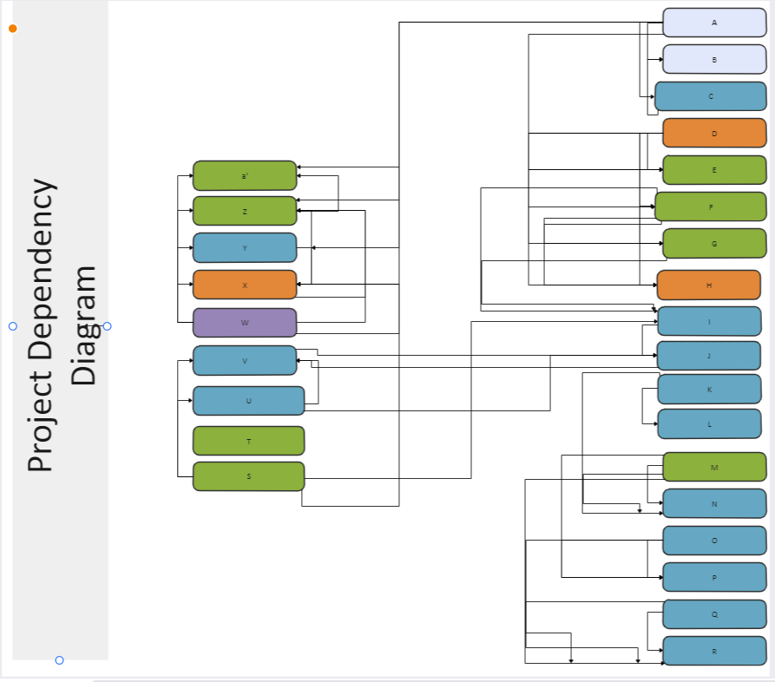

**Attributes closure**:

a+ = {a,b,c}

b+ = {b}

c+ = {b,c}

d+ = {d,e,f,g,h}

e+ = {e,}

f+ = {f,g,h}

g+ = {g}

h+ = {h}

i+ = {i,j}

j+ = {j}

k+ = {k,l}

l+ = {l}

m+ = {m,n}

n+ = {n}

o+ = {o,p}

q+ = {q,r}

r+ = {r}

s+ = {s,t,u,v}

t+ = {t}

u+ = {u}

v+ = {v}

w+ = {w,x,y,z,a1}

x+ = {x}

y+ = {y}

z+ = {z,a1}

a1+ = {a1}

**CANONICAL COVER:**

a -> c

c -> b

d -> ef

f -> d,g,h

I -> j

K -> l

M -> n

O -> p

Q -> r

S -> iu

Ju -> v

Uv -> j

w -> y

z -> a1

yz -> x

w -> z

**CANDIDATE KEY:**

a,k,m,o,q,s,t,w,d

a,k,m,o,q,s,t,w,f

**SUPER KEYS:**

a,k,m,o,q,s,t,w,d

a,k,m,o,q,s,t,w,f

a

c

a,d

d

f,g

f

i

i,k

io

km

mo

moq

k

m

o

q

s

ju

uv

w

z

yz

wx

asw

**UNNORMALIZED TABLE:**

create table meter_analysis(server_no varchar2(10) ,server_code int ,sever_location varchar2(50),  
meter_id int,area varchar(80),employee_id varchar2(30), Meter_number varchar2(10), Meter_Registration varchar2(10),  
city_code int,city_name varchar(30),  
area_code int,area_name varchar(30),  
community_code int,community_name varchar(30),  
crosses_code int,crosses_name varchar(100),  
appartment_code int ,population int,  
house_no varchar2(30), owner_name varchar2(100), owner_phno varchar2(100),house_meter varchar2(100),  
member_id varchar2(10) ,member_name varchar2(100),member_serials varchar2(20),  
complaint_id int,compl_reason varchar(70));  
insert into meter_analysis values('S01',1234,'maya bazzar',  
190,'swathi nagar 2nd street',  
'EI400', 'MN3001','RWMQ21',  
123,'vishakapatnam',  
101,'vizianagaram',  
120,'knagar',  
1,'1ST CROSS ,RANGANADHAM COLONY',  
801,2400,  
'VM-23/4334', 'KRISHNA', '9874563215, 7744112586', 'SINGLE JET WATER METER',  
'M01','krishna','S01AB7857',  
123,'severe shortage of water supply' );

insert into meter_analysis values('S02',5874,'state bank colony',192,'madhura nagar beside ankul school',  
'EI410','MN4002', 'RWMQ22',213,'vijayawada',204, 'ramnagar',450, 'mgpur',2,'2ND CROSS ,STATE BANK COLONY',274,  
3100, 'SK-99/1001', 'ROHIT', '8523697415', 'SINGLE JET WATER METER','M02','vikram', 'S01AB8389',122, 'no water supply since last 6 days' );

insert into meter_analysis values('S03',7864,'vinayaka nagar',194,'murali nagar 4th line',  
'EI420','MN5003', 'RWMQ23',453,'coimbatore',701, 'ettimadai',781, 'kl nagar',3,'3RD CROSS ,SRK C OLONY',451,  
4120, 'KL-54/5566', 'VIKRAM', '7894512632, 6654987123', 'PLASTIC WATER METER','M03','satyanath', 'S05JI8239',124, 'The water is coming with a bad smell' );

 insert into meter_analysis values('S04',5278,'gandhipuram',196    ,'asifguda beside akash school',  
'EI430','MN6004', 'RWMQ24',473,'hyderabad',456, 'madhapur',784, 'pp nagar',4,'4TH CROSS ,VIDYA NAGAR',445,  
1540, 'SO-85/4334', 'HARSHA', '6395287415', 'EEC/MID WATER METER','M04','sarath', 'S04HU8928',125, 'bleaching is more' );

insert into meter_analysis values('S05',9019,'main road',199,'kota bazar beside khan jwellers',  
'EI440','MN7005', 'RWMQ25',784,'chennai',710, 'chennai hill',156, 'kk puram',5,'5TH CROSS ,SARABHAI NAGAR',548,  
2500, 'GM-33/4334', 'MEHER', '9988456321,9513574628', 'EEC/MID WATER METER','M05','Ritwik', 'S08KO8913',126, 'water is not coming on time' );

insert into meter_analysis values(' ',null,' ',null,' ',  
' ',' ', ' ',null,' ',null, ' ',null, ' ',null,' ',null,  
null, ' ', ' ', ' ', 'PLASTIC WATER METER','M06','saurabh singh', ' ',null, ' ');

insert into meter_analysis values('  ',null,' ',null,' ',  
' ',' ', ' ',null,' ',null, ' ',null, ' ',null,' ',null,  
null, ' ', ' ', ' ', 'SINGLE JET WATER METER','M07','lal rai', ' ',null, ' ');

insert into meter_analysis values(' ',null,' ',null,' ',  
' ',' ', ' ',null,' ',null, ' ',null, ' ',null,' ',null,  
null, ' ', ' ', ' ', 'MULTI WATER METER','M08','vinay pandey', ' ',null, ' ');

insert into meter_analysis values(' ',null,' ',null,' ',  
' ',' ', ' ',123,'vishakapatnam',101, 'vizianagaram',120, 'knagar',1,'1ST CROSS ,RANGANADHAM COLONY',801,  
2400, 'SV-6-798', 'ABHINAV RAJ', ' 7531596497',' ', ' ',' ', ' ',null, ' ');

insert into meter_analysis values(' ',null,' ',null,' ',  
' ',' ', ' ',123,'vishakapatnam',101, 'vizianagaram',120, 'knagar',1,'1ST CROSS ,RANGANADHAM COLONY',801,  
2400, 'MM-23-111', 'MENAKA KRISHNA', ' 7531544421',' ',  ' ',' ', ' ',null, ' ');

insert into meter_analysis values(' ',null,' ',null,' ',  
' ',' ', ' ',123,'vishakapatnam',101, 'vizianagaram',120, 'knagar',1,'1ST CROSS ,RANGANADHAM COLONY',801,  
2400, 'LX-33-441', 'LAKSHMAN', ' 9881114426',' ', ' ',' ', ' ',null, ' ');

insert into meter_analysis values(' ',null,' ',null,' ',  
' ',' ', ' ',123,'vishakapatnam',101, 'vizianagaram',120, 'knagar',1,'1ST CROSS ,RANGANADHAM COLONY',801,  
2400, 'NX-43-122', 'VIMAL', ' 7531544421',' ', ' ',' ', ' ',null, ' ');

select * from meter_analysis;

**OUTPUT:**

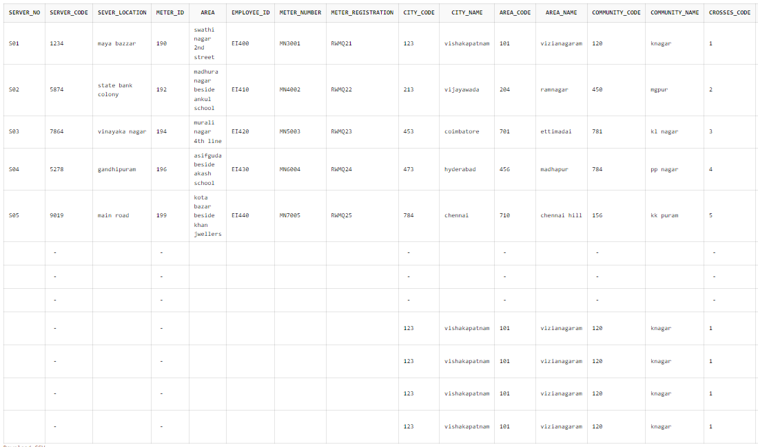

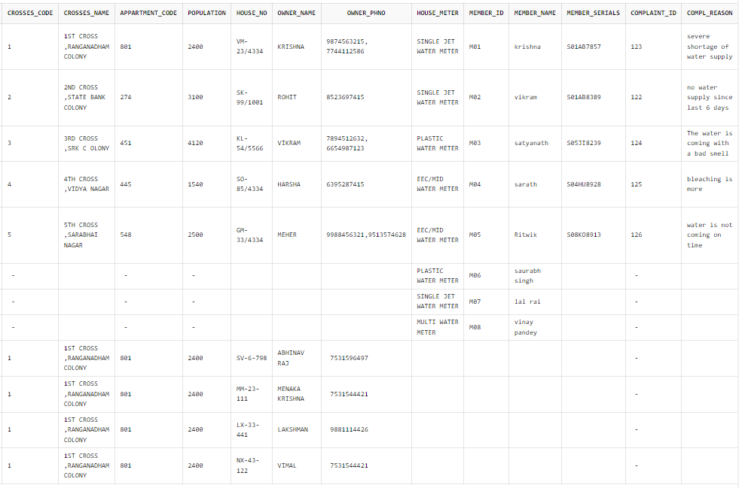

**Anamolies**

1.Non-atomic:

* owner_phno
* crosses_name

2.Null primary key:

* server_no
* server_code
* meter_id
* employee_id
* area_code
* community_code
* cross_code
* house_no
* complaint_id
* member_id

3.Similar Rows:

* city_code
* city_name
* area_code
* area_name
* communiy_code
* community_name
* cross_code
* cross_name
* appartment_code
* population

**1NF Diagram:**

create table city(

city_code int primary key,

city_name varchar(30),

area_code int,

area_name varchar(30),

community_code int,

community_name varchar(30),

crosses_code int,

crosses_name varchar(30),

appartment_code int,

population int);

insert into city values(123,'vishkapatnam',101,'vizianagaram',120,'knagar',1,'Ranganadham colony',801,2400);

insert into city values(213,'vijayawada',204,'ramnagar',450,'mgpur',2,'state bank colony',274,3100);

insert into city values(453,'coimbatore',701,'ettimadai',781,'klnagar',3,'srk colony',451,4120);

insert into city values(473,'hyderabad',456,'madhapur',784,'ppnagar',4,'vidhyanagar',445,1540);

insert into city values(784,'chennai',710,'chennai hill',156,'k kpuram',5,'sarabhai nagar',548,2500);

create table house(

house_meter varchar(30),

member_id varchar(30) primary key,

member_name varchar(30));

insert into house values('SINGLE JET WATER METER','M01','Krishna');

insert into house values('SINGLE JET WATER METER','M02','vikram');

insert into house values('PLASTIC WATER METER','M03','Satyanath');

insert into house values('EEC/MID WATER METER','M04','Sarath');

insert into house values('EEC/MID WATER METER','M05','Ritwik');

insert into house values('PLASTIC WATER METER','M06','saurabh singh');

insert into house values('SINGLE JET WATER METER','M07','lal rai');

insert into house values('MULTI WATER METER','M08','Vinay pandey');

Select * from city;

Select * from house;

create table details(

city_code int,

member_id varchar(30),

server_no varchar(30),

server_code int,

server_location varchar(30),

meter_id int,

area varchar(100),

employee_id varchar(30),

meter_no varchar(30),

meter_registration varchar(30),

member_serials varchar(30),

complaint_id varchar(30),

complaint_reason varchar(100));

insert into details values(123,'M01','S01',1234,'mayabazar',190,'swathi nagar 2nd street','EI400','MN3001','RWMQ21','S01AB7857',123,'severe shortage of water supply');

insert into details values(213,'M02','S02',5874,'statebank colony',192,'madhuranagar nagar beside ankul school','EI410','MN4002','RWMQ22','S01AB8389',122,'no water supply since six days');

insert into details values(453,'M03','S03',7864,'vinayakanagar',194,'murali nagar 2nd street','EI420','MN5002','RWMQ23','S05JI8239',124,'the water coming with bad smell');

insert into details values(473,'M04','S04',5278,'gandipuram',196,'asiggida beside aksh school','EI430','MN6004','RWMQ24','S04HU8928',125,'bleaching is more');

insert into details values(784,'M05','S05',9019,'mainroad',199,'kota bazar beside khan jewellary','EI440','MN7005','RWMQ25','S08KO8913',126,'water is not coming on time');

select * from details;

create table owner(

city_code int,

house_no varchar(30) ,

owner_name varchar(30),

owner_phno int primary key);

insert into owner values(123,'VM-23/4334','krishna',9874563215);

insert into owner values(123,'VM-23/4334','krishna',7744112586);

insert into owner values(213,'SK-99/1001','rohith',8523697415);

insert into owner values(453,'KL-54/5566','vikram',7894512632);

insert into owner values(453,'KL-54/5566','vikram',6655987123);

insert into owner values(473,'SO-85/4334','harsha',6315287415);

insert into owner values(784,'GM-33/4334','meher',9988456321);

insert into owner values(784,'GM-33/4334','meher',9513574628);

insert into owner values(123,'SV-6/798','abhinav',7531596497);

insert into owner values(123,'MM-23-111','menaka krishna',753154421);

insert into owner values(123,'LX-33-441','laxman',988596497);

insert into owner values(123,'NX-43122','vimal',7531544497);

select * from owner;

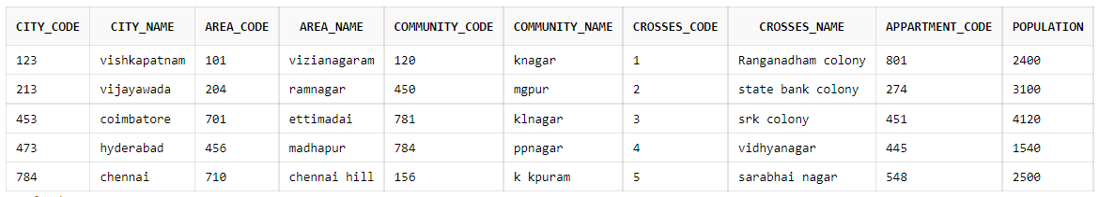

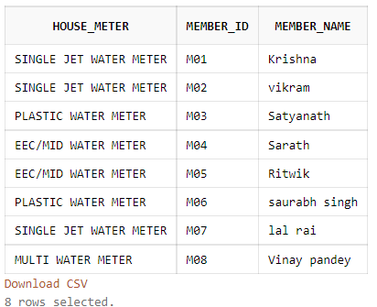

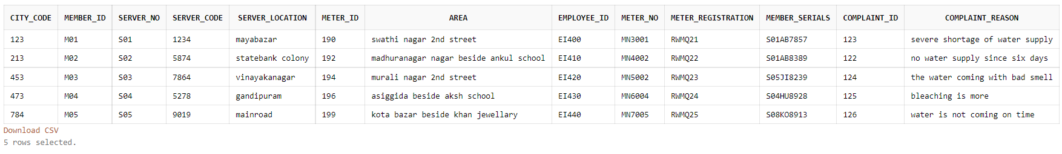

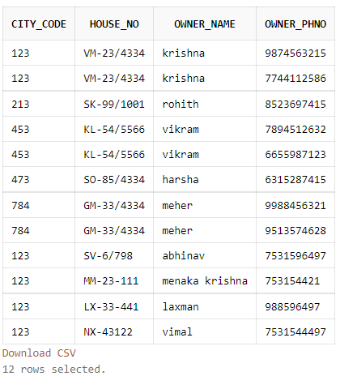

**Partial dependencies:**

1)vw -> x and w -> x

2)isu -> t and u -> t

**Dependences for 2nf after removing partial dependencies:**

w -> x

v -> x

u -> t

u -> si

a->c  
c->b  
d->e  
f->h,g  
i->j  
k->l  
m->n  
o->p  
q->r  
s->iu  
ju->v  
uv->j  
w->yz  
z->a1  
yz->x  
d->f  
f->d

**2nf diagram:**

create table house(

house_meter varchar(30),

member_id varchar(30) primary key);

insert into house values('SINGLE JET WATER METER','M01');

insert into house values('SINGLE JET WATER METER','M02');

insert into house values('PLASTIC WATER METER','M03');

insert into house values('EEC/MID WATER METER','M04');

insert into house values('EEC/MID WATER METER','M05');

insert into house values('PLASTIC WATER METER','M06');

insert into house values('SINGLE JET WATER METER','M07');

insert into house values('MULTI WATER METER','M08');

create table house1(

member_id varchar(30) primary key,

member_name varchar(30));

insert into house1 values('M01','Krishna');

insert into house1 values('M02','vikram');

insert into house1 values('M03','Satyanath');

insert into house1 values('M04','Sarath');

insert into house1 values('M05','Ritwik');

insert into house1 values('M06','saurabh singh');

insert into house1 values('M07','lal rai');

insert into house1 values('M08','Vinay pandey');

select * from house;

select * from house1;

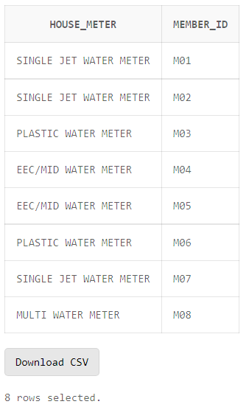

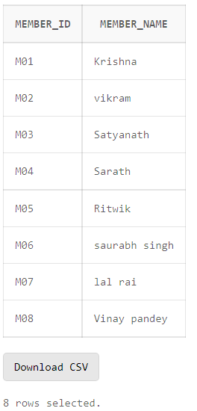





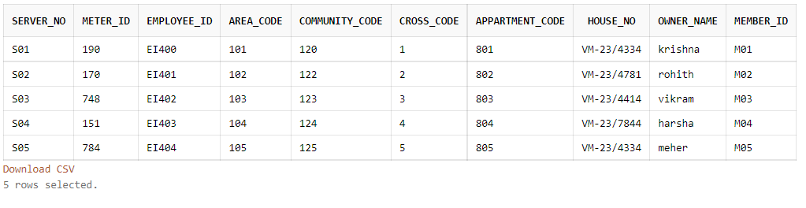



**TRANSITIVE DEPENDENCIES:**

a -> c and a -> b and c->b

w -> z and z -> a1 and w -> a1

y -> z and z -> a1 and y->a1

**Dependences for 3nf after removing transitive dependencies:**

a->c  
c->b  
d->e  
f->h,g  
i->j  
k->l  
m->n  
o->p  
q->r  
s->iu  
ju->v  
uv->j  
w->yz  
z->a1  
yz->x  
d->f  
f->d

**3nf diagram:**

create table server1(server_no varchar(30),server_location varchar(100));

create table server2(server_code int,server_location varchar(100));

create table marea(meter_id varchar(100),area varchar(100));

create table emp(employee_id varchar(100),meter_no varchar(100),meter_registration varchar(100));

create table city(city_code int,city_name varchar(100));

create table area(area_code int,area_name varchar(100));

create table comm(community_name varchar(30),community_code int);

create table crosses(cross_code int,cross_name varchar(100));

create table appt(appartment_code int,population int);

create table house(house_no varchar(100),owner_phno int,city_code int);

create table chouse(city_name varchar(100),owner_phno int,house_meter varchar(100));

create table memb(member_id varchar(100),member_serial varchar(100),complaint_id int);

create table comp(complaint_id int,complaint_registration varchar(100));

create table cmemb(memner_name varchar(100),member_serial varchar(100),complaint_id int);

create table details(server_no varchar(100),meter_id varchar(100),employee_id varchar(100),area_code int,community_code int,cross_code int,appartment_code int,house_no varchar(100),owner_name varchar(100),member_id varchar(100));

insert into server1 values('S01','maya bazzar ');

insert into server1 values('S02','state bank colony');

insert into server1 values('S03','vinayaka nagar');

insert into server1 values('S04','gandhipuram');

insert into server1 values('S05','main road');

insert into server2 values(1234,'maya bazzar ');

insert into server2 values(5874,'state bank colony');

insert into server2 values(7864,'vinayaka nagar');

insert into server2 values(5278,'gandhipuram');

insert into server2 values(9019,'main road');

insert into marea values(190,'swathi nagar 2nd street');

insert into marea values(192,'madhura nagar beside ankul school');

insert into marea values(194,'murali nagar 4th line');

insert into marea values(196,'asifguda beside akash school');

insert into marea values(199,'kota bazar beside khan jwellers');

insert into emp values('EI400', 'MN3001', 'RWMQ21');

insert into emp values('EI410', 'MN4002', 'RWMQ22');

insert into emp values('EI420', 'MN5003', 'RWMQ23');

insert into emp values('EI430', 'MN6004', 'RWMQ24');

insert into emp values('EI440', 'MN7005', 'RWMQ25');

insert into city values(123,'vishakapatnam');

insert into city values(213,'vijayawada');

insert into city values(453,'coimbatore');

insert into city values(473,'hyderabad');

insert into city values(784,'chennai');

insert into area values(101,'vizianagaram');

insert into area values(204,'ramnagar');

insert into area values(701,'ettimadai');

insert into area values(456,'madhapur');

insert into area values(710,'chennai hill');

insert into comm values('knagar',120);

insert into comm values('mpur',450);

insert into comm values('kl nagar',781);

insert into comm values('pp nagar',784);

insert into comm values('kk puram',156);

insert into crosses values(1, '1ST CROSS ,RANGANADHAM COLONY');

insert into crosses values(2, '2ND CROSS ,STATE BANK COLONY');

insert into crosses values(3, '3RD CROSS ,SRK COLONY');

insert into crosses values(4, '4TH CROSS ,VIDYA NAGAR');

insert into crosses values(5, '5TH CROSS ,SARABHAI NAGAR');

insert into appt values(801,2400);

insert into appt values(274,3100);

insert into appt values(451,4120);

insert into appt values(445,1540);

insert into appt values(548,2500);

insert into house values('VM-23/4334', 7744112586,123);

insert into house values('SK-99/1001',8523697415,213);

insert into house values('KL-54/5566', 6654987123,453);

insert into house values('SO-85/4334', 6395287415,473);

insert into house values('GM-33/4334', 9513574628,784);

insert into chouse values('vishakapatnam',9874563215, 'PLASTIC WATER METER');

insert into chouse values('vizayawada',8523697415, 'SINGLE JET WATER METER');

insert into chouse values('coimbatore', 6654987123, 'PLASTIC WATER METER');

insert into chouse values('hyderbad',6395287415, 'EEC/MID WATER METER');

insert into chouse values('chennai',9988456321, 'EEC/MID WATER METER');

insert into memb values('M01','S01AB7857',123);

insert into memb values('M02','S01AB8389',122);

insert into memb values('M03','S05JI8239',124);

insert into memb values('M04','S04HU8928',125);

insert into memb values('M05','S08KO8913',126);

insert into comp values(123,'severe shortage of water supply' );

insert into comp values(122,'no water supply since last 6 days');

insert into comp values(124,'The water is coming with a bad smell' );

insert into comp values(125,'bleaching is more');

insert into comp values(126,'water is not coming on time');

insert into cmemb values('krishna','S01AB7857',123);

insert into cmemb values('meher','S01AB8389',122);

insert into cmemb values('harsha','S05JI8239',124);

insert into cmemb values('rohit','S04HU8928',125);

insert into cmemb values('vikram','S08KO8913',126);

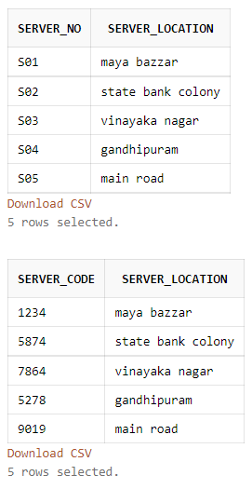



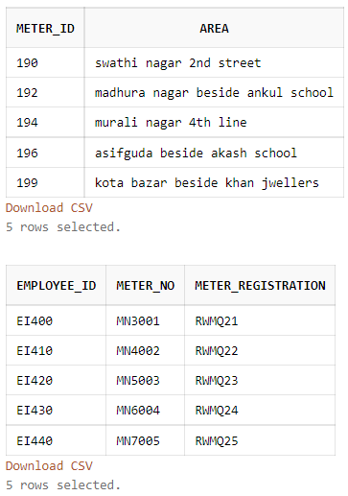

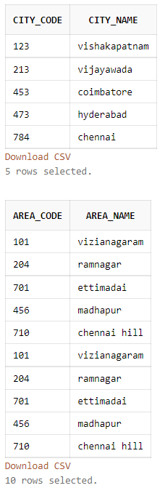

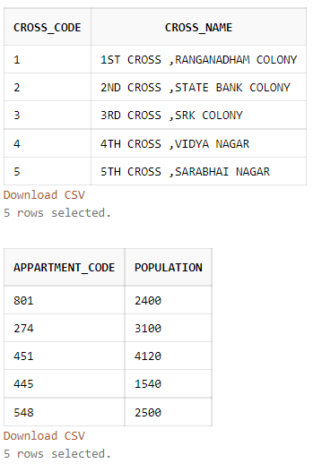

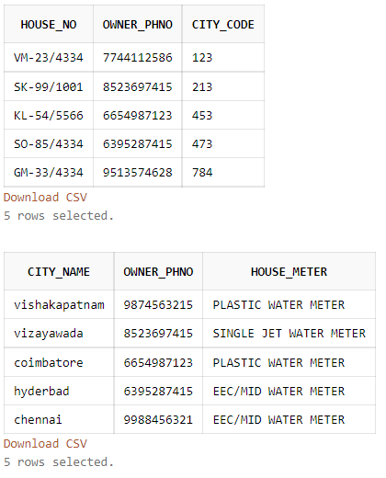

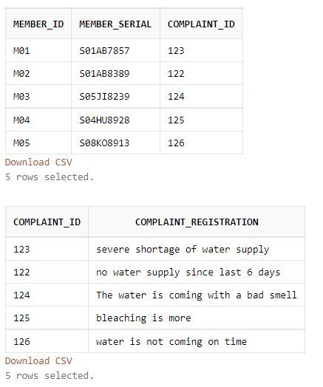

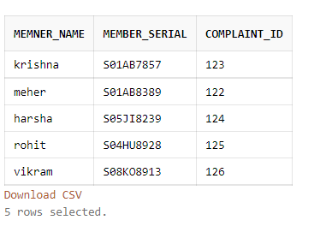

**BCNF:**

3NF tables satisfying the BCNF conditions.

SO SAME AS 3NF TABLES ARE DECOMPOSED.

**LOSSLESS DECOMPOSITION:**

|  |  |  |  |  |  |  |  |  |  |  |  |  |  |  |  |  |  |  |  |  |  |  |  |  |  |  |
| --- | --- | --- | --- | --- | --- | --- | --- | --- | --- | --- | --- | --- | --- | --- | --- | --- | --- | --- | --- | --- | --- | --- | --- | --- | --- | --- |
|  | a | b | c | d | e | f | g | h | i | j | k | l | m | n | o | p | q | r | s | u | v | w | x | y | z | a1 |
| ac | A | X | A |  |  |  |  |  |  |  |  |  |  |  |  |  |  |  |  |  |  |  |  |  |  |  |
| Cb |  | A | A |  |  |  |  |  |  |  |  |  |  |  |  |  |  |  |  |  |  |  |  |  |  |  |
| De |  |  |  | A | A | X | X | X |  |  |  |  |  |  |  |  |  |  |  |  |  |  |  |  |  |  |
| Fhg |  |  |  |  |  | A | A | A |  |  |  |  |  |  |  |  |  |  |  |  |  |  |  |  |  |  |
| Ij |  |  |  |  |  |  |  |  | A | A |  |  |  |  |  |  |  |  |  |  |  |  |  |  |  |  |
| Kl |  |  |  |  |  |  |  |  |  |  | A | A |  |  |  |  |  |  |  |  |  |  |  |  |  |  |
| Mn |  |  |  |  |  |  |  |  |  |  |  |  | A | A |  |  |  |  |  |  |  |  |  |  |  |  |
| Op |  |  |  |  |  |  |  |  |  |  |  |  |  |  | A | A |  |  |  |  |  |  |  |  |  |  |
| Qr |  |  |  |  |  |  |  |  |  |  |  |  |  |  |  |  | A | A |  |  |  |  |  |  |  |  |
| Sui |  |  |  |  |  |  |  |  | A | X |  |  |  |  |  |  |  |  | A | A |  |  |  |  |  |  |
| Juv |  |  |  |  |  |  |  |  |  | A |  |  |  |  |  |  |  |  |  | A | A |  |  |  |  |  |
| Wzy |  |  |  |  |  |  |  |  |  |  |  |  |  |  |  |  |  |  |  |  |  | A |  | A | A |  |
| Za1 |  |  |  |  |  |  |  |  |  |  |  |  |  |  |  |  |  |  |  |  |  |  |  |  | A | A |
| Yzx |  |  |  |  |  |  |  |  |  |  |  |  |  |  |  |  |  |  |  |  |  |  | A | A | A |  |
| Adfkm  oqstw | A | A | X | A | X | A | X | X | X | X | A | X | A | X | A | X | A | X | A | X | X | A | X | X | X | A |

**Dependence preserving:**

R1(a,c)  
a->c

R2(c,b)  
c->b

R3(d,c)  
d->c

R4(f,h,g)  
f->gh

R5(i,j)  
i->j

R6(k,l)  
k->l

R7(m,n)  
m->n

R8(o,p)  
o->p

R9(q,r)  
q->r

R10(s,i,u)  
s->u

R11(j,u,v)  
uv->j  
ju->v

R12(w,y,z)  
w->y  
w->z

R13(z,a1)  
z->a1

R14(y,z,x)  
yz->x

R15(d,f)  
d->f

R16(f,d)  
d->f

This is dependence preserving decomposition

**Primary keys for normalized table:**

Server_no

Server_location

Meter_id

Employee_id

City_code

Area_code

Community_code

Crosses_code

Appt_code

House_no

City_name,owner_phno

Owner_phno,house_meteter

Meter_id

Complaint_id

Member_serial,complaint_id

**Dependency diagram after normalization:**

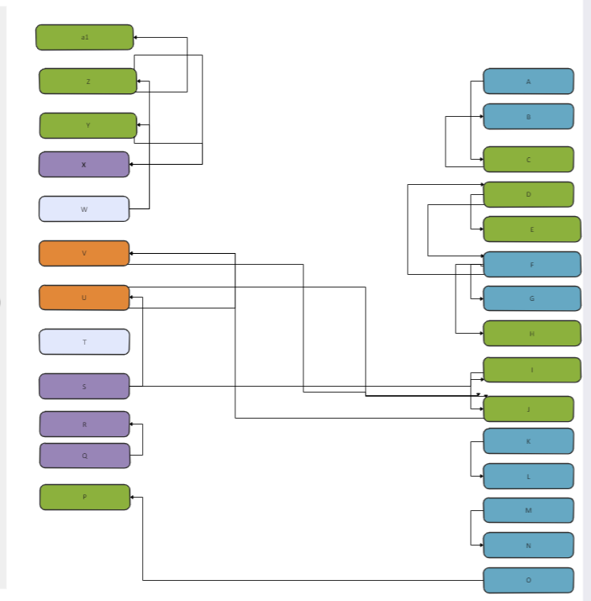

**UI DESIGN:**

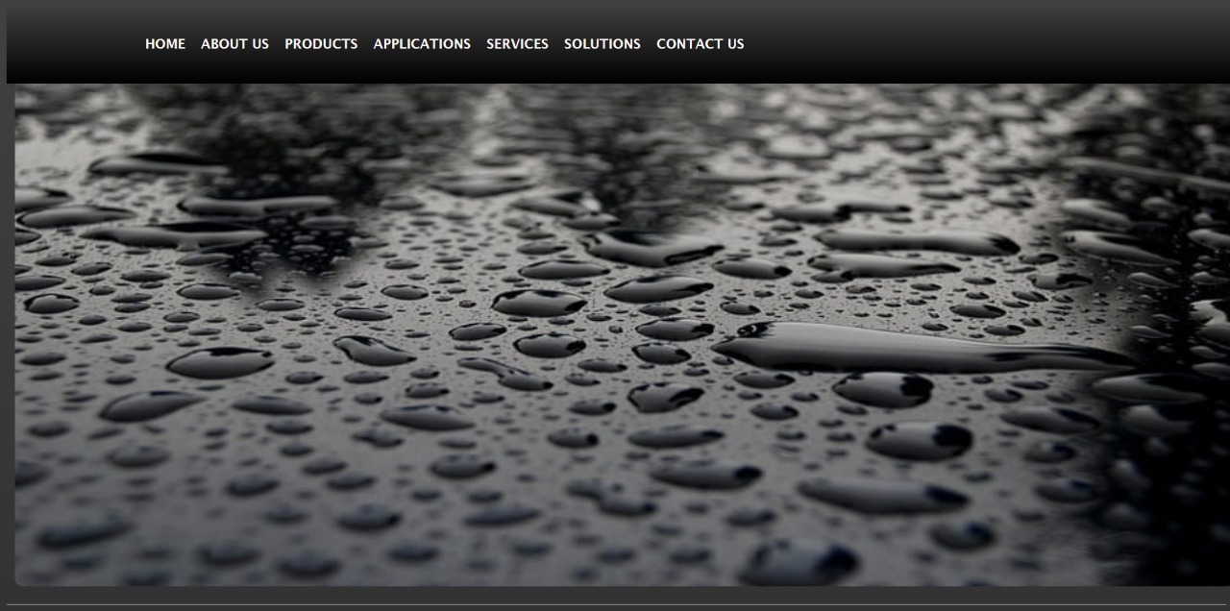

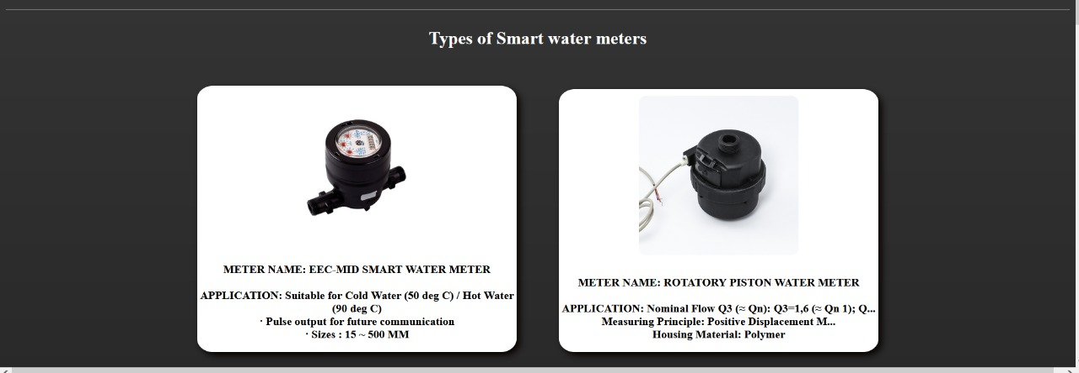

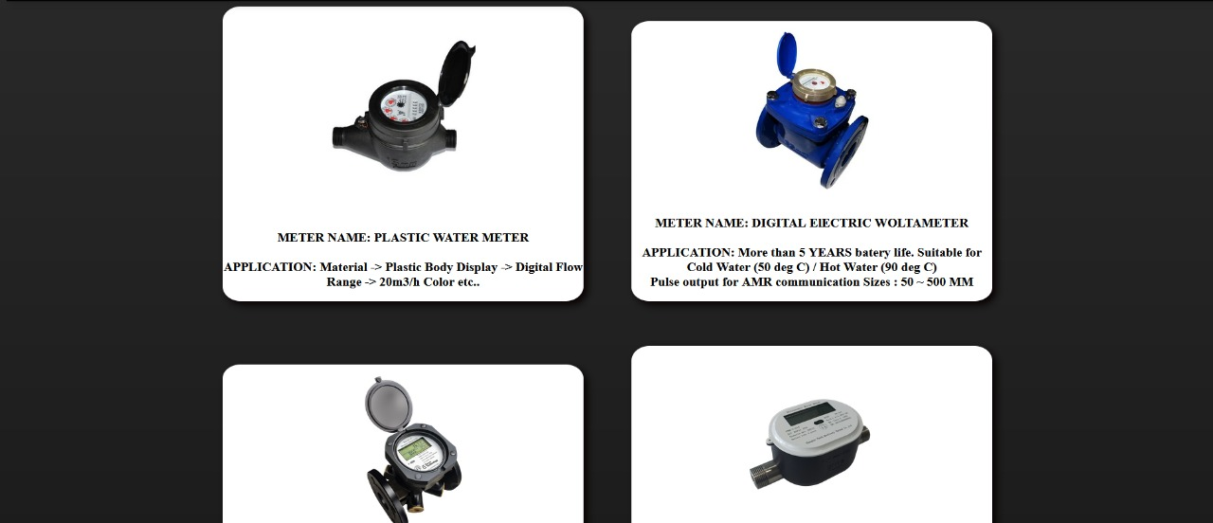

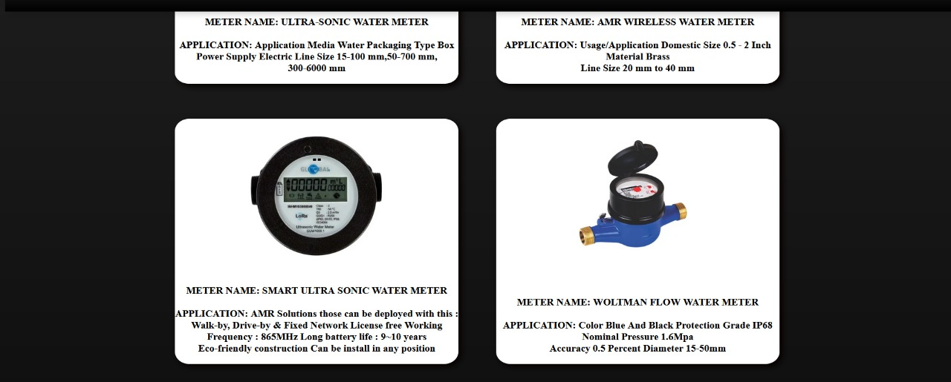

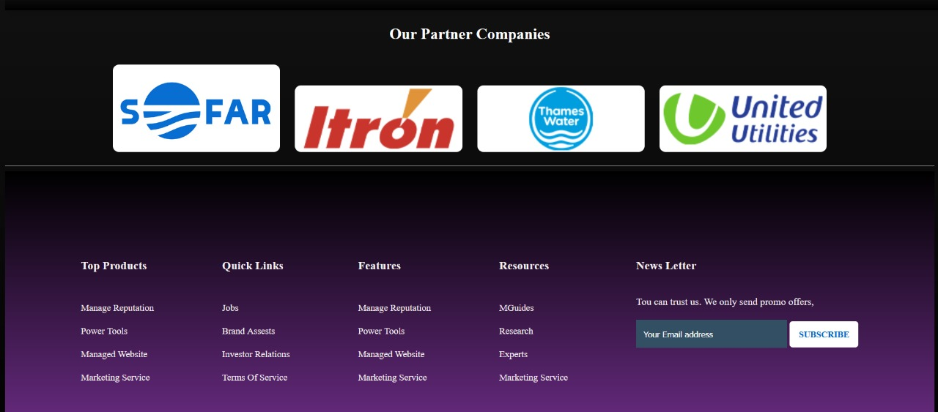

**REFERENCES:**

[**https://unsplash.com/s/photos/water-meter**](https://unsplash.com/s/photos/water-meter)

[**https://www.peltekindia.in/smart-water-meter-C-37.html**](https://www.peltekindia.in/smart-water-meter-C-37.html)

[**https://www.wegot.in/blog/understanding-the-different-types-of-water-meters/**](https://www.wegot.in/blog/understanding-the-different-types-of-water-meters/)

[**https://www.indiamart.com/proddetail/amr-wireless-water-meter-22814774062.html**](https://www.indiamart.com/proddetail/amr-wireless-water-meter-22814774062.html)

[**http://www.ict.griffith.edu.au/normalization_tools/normalization/ind.php#findMinimalCover**](http://www.ict.griffith.edu.au/normalization_tools/normalization/ind.php#findMinimalCover)